Chip back potential is the level which bulk silicon is maintained by on-chip connection, or it is the level to which the chip back must be connected when specifically stated below. If no potential is given the chip back should be isolated.

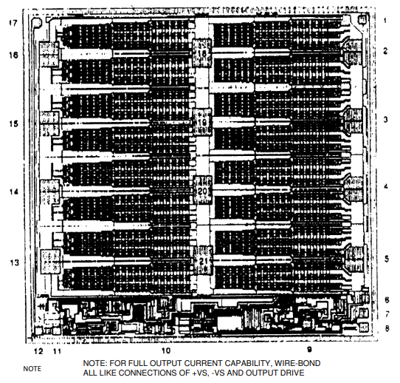
PAD FUNCTIONS:

- NC
- -V_{S}
- -V_{S}
- -V_{S}
- -V_{S}
- NC
- -IN
- +IN
- NC
- NC
- NC
- CURRENT SENSE
- +V_{S}
- +V_{S}
- +V_{S}
- +V_{S}
- CURRENT SENSE
- OUTPUT DRIVE
- OUTPUT DRIVE
- OUTPUT DRIVE
- OUTPUT DRIVE

Top Material: Al
Backside Material: CrNiAg
Bond Pad Size: .004 X .004” min.
Backside Potential: -Vs
Mask Ref:

APPROVED BY: DK DIE SIZE .214” X .205” DATE: 9/28/22
MFG: TEXAS INSTRUMENTS THICKNESS .000” P/N: OPA541SD
DG 10.1.2

Rev B, 7/19/02

